AWS CLOUD COMPUTING LABORATORY
COMPLETE PRACTICAL DOCUMENTATION
Submitted by:
Name | Vishva Kumar B
Register Number | 722824148119
Class | B
Department | AIML
Academic Year | 2026–2027
Subject | AWS Cloud Computing Lab / Practical

TABLE OF CONTENTS
S.No | Question Title | Page
1 | AWS-Based Healthcare Dataset Preprocessing Using Amazon S3 and Amazon SageMaker  Design and implement a secure AWS infrastructure to store a patient dataset in Amazon S3 and preprocess it using an Amazon SageMaker notebook within a selected VPC and subnet.  The workflow handles missing values, encodes categorical attributes, and scales numerical features using Pandas, NumPy, and Scikit-learn. | 3

Question 1
Vishva Kumar B | AWS Cloud Practical | 2026–2027

1. Title
Design and implementation of a highly available, scalable and secure AWS infrastructure for an application that experiences a 50× increase in traffic for 24 hours.

2. Aim
To design a secure AWS workflow that stores a patient dataset in Amazon S3 and preprocesses it using an Amazon SageMaker notebook inside a selected VPC and subnet.

3. Problem Description
- A healthcare analytics company needs to prepare a patient dataset for machine-learning model development. The raw data must be securely stored in S3, loaded directly into SageMaker, cleaned and transformed using Pandas, NumPy and Scikit-learn, and saved back to S3.

4. Requirements
- Amazon S3 bucket with Block Public Access and server-side encryption.
- SageMaker notebook instance configured within a selected VPC and subnet.
- IAM role with minimum required permissions to read and write the S3 objects.
- Python libraries: Pandas, NumPy and Scikit-learn.
- Preprocessing: missing-value handling, categorical encoding and numerical feature scaling.
- Store the final processed dataset in an S3 processed/ folder.

5. Cloud Infrastructure / Architecture Diagram
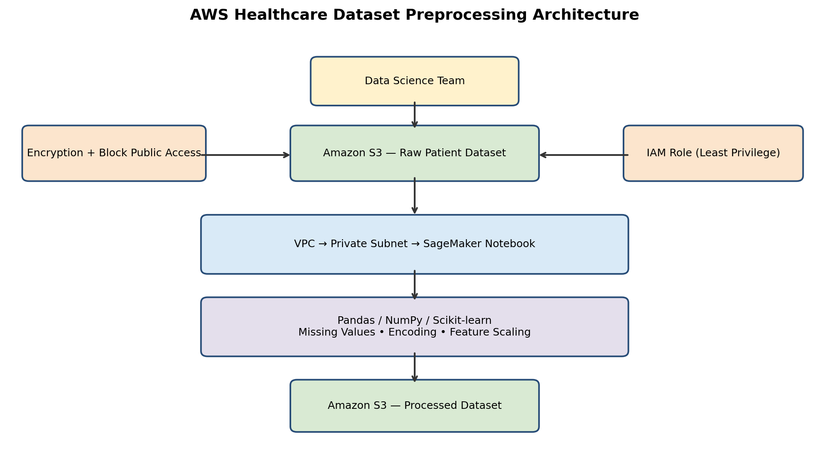
Figure 1: Raw dataset flows from S3 to SageMaker for preprocessing and returns to S3 as a processed dataset.
Role of main components:
- Route 53 / CloudFront – route users to the application and cache static content at the edge (optional layer).
- Application Load Balancer – internet-facing; spreads requests across healthy instances in both Availability Zones and runs health checks.
- Auto Scaling Group – launches or terminates EC2 instances automatically and replaces unhealthy ones.
- Amazon RDS – managed database used by all instances so the application tier stays stateless.
- Amazon S3 – object and file storage, and backups.
- Amazon CloudWatch – collects metrics and raises alarms; drives the CPU-based scaling policy.
- CodePipeline / CodeBuild / CodeDeploy – build, test and deploy new application versions to the Auto Scaling Group.
- Security groups – the ALB accepts HTTP/HTTPS from the internet; EC2 instances accept traffic only from the ALB.

6. Procedure / Implementation Steps
Scaling configuration used:
Setting | Value
Minimum instances | 2
Desired instances | 2
Maximum instances | 6
Scaling metric | CPU utilization (target tracking)
Target CPU | 50%
Availability Zones | 2 (ap-south-1a, ap-south-1b)
Region | Asia Pacific (Mumbai) ap-south-1

- Security groups: Create a security group for the ALB (inbound HTTP 80 / HTTPS 443 from 0.0.0.0/0) and a security group for the EC2 instances (inbound HTTP 80 only from the ALB security group).
- Launch Template: Create the Launch Template Marketing-App-Template (Version 1) with the AMI of the application, instance type, key pair, the EC2 security group and user data to start the web servRDS: Create an Amazon RDS database (Multi-AZ preferred) in private subnets; its security group allows the database port only from the EC2 security group.
- CloudWatch: Create alarms for CPUUtilization, UnHealthyHostCount, TargetResponseTime and HTTPCode_Target_5XX_Count with notifications.
- CI/CD: Connect the GitHub repository to CodePipeline. CodeBuild builds and tests the code (buildspec.yml); CodeDeploy (appspec.yml) deploys the new version to the instances of Marketing-ASG.
Console screens captured during implementation:

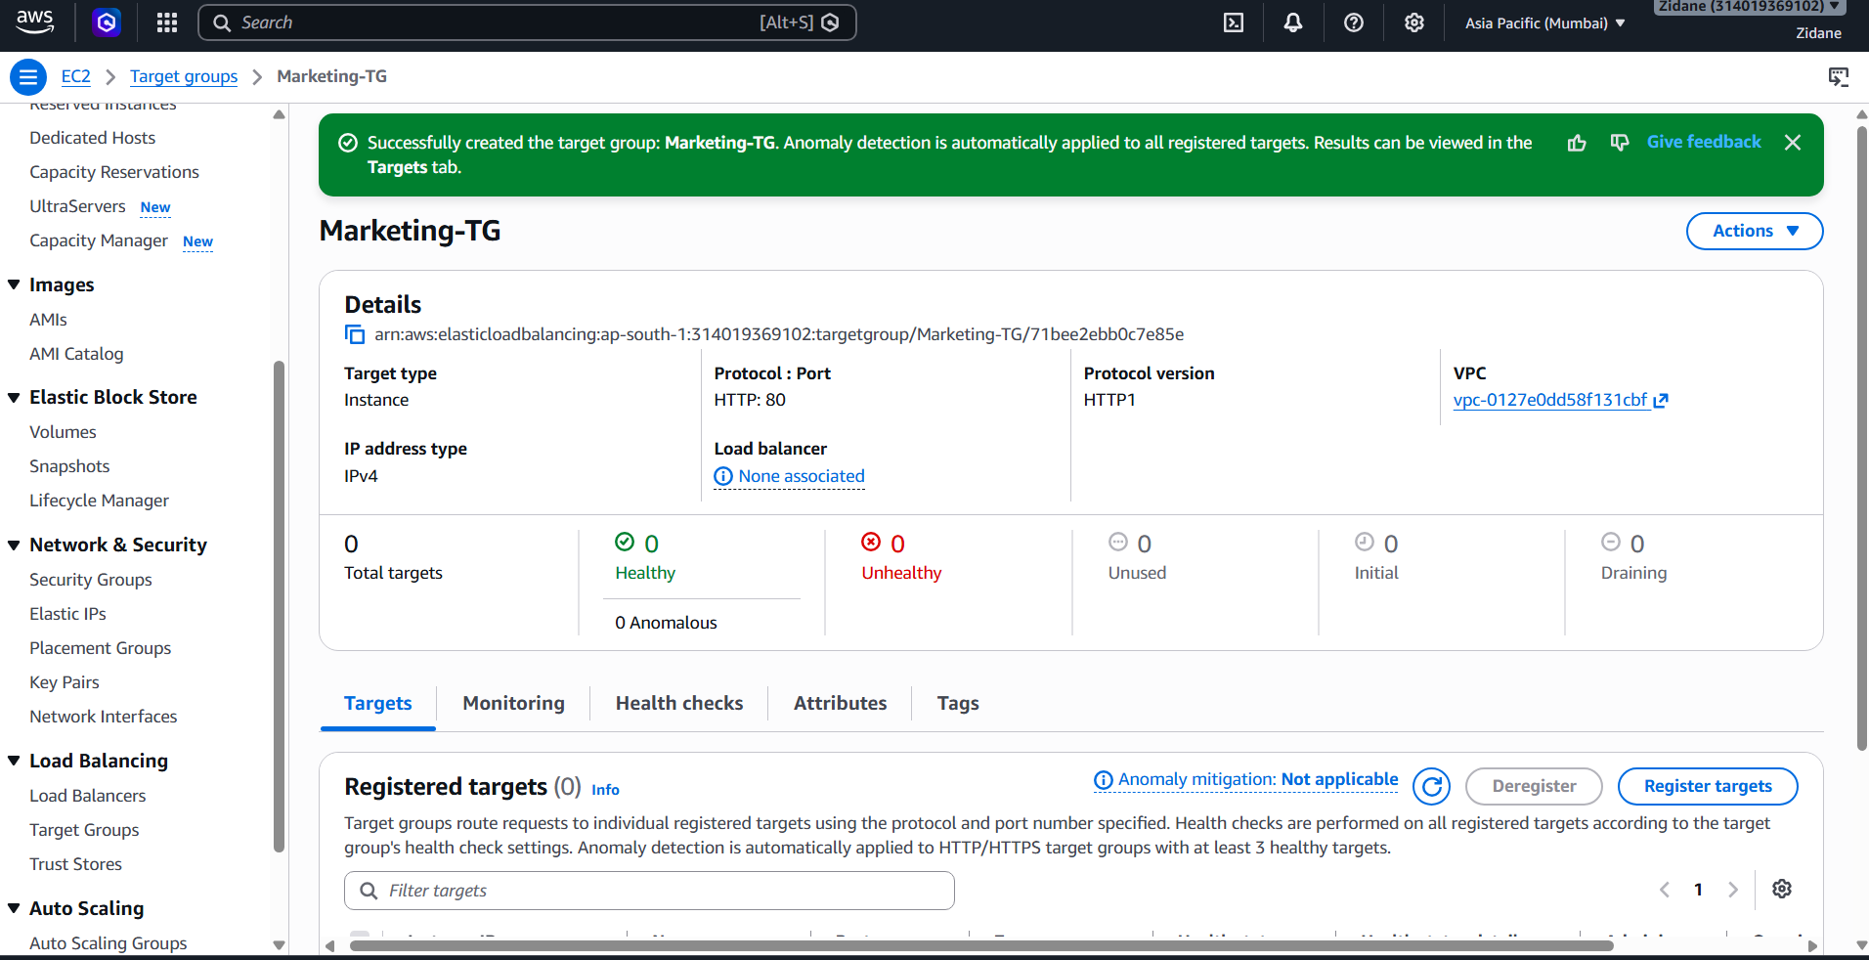
Figure 2: Target group Marketing-TG created (Instance, HTTP:80, HTTP1)
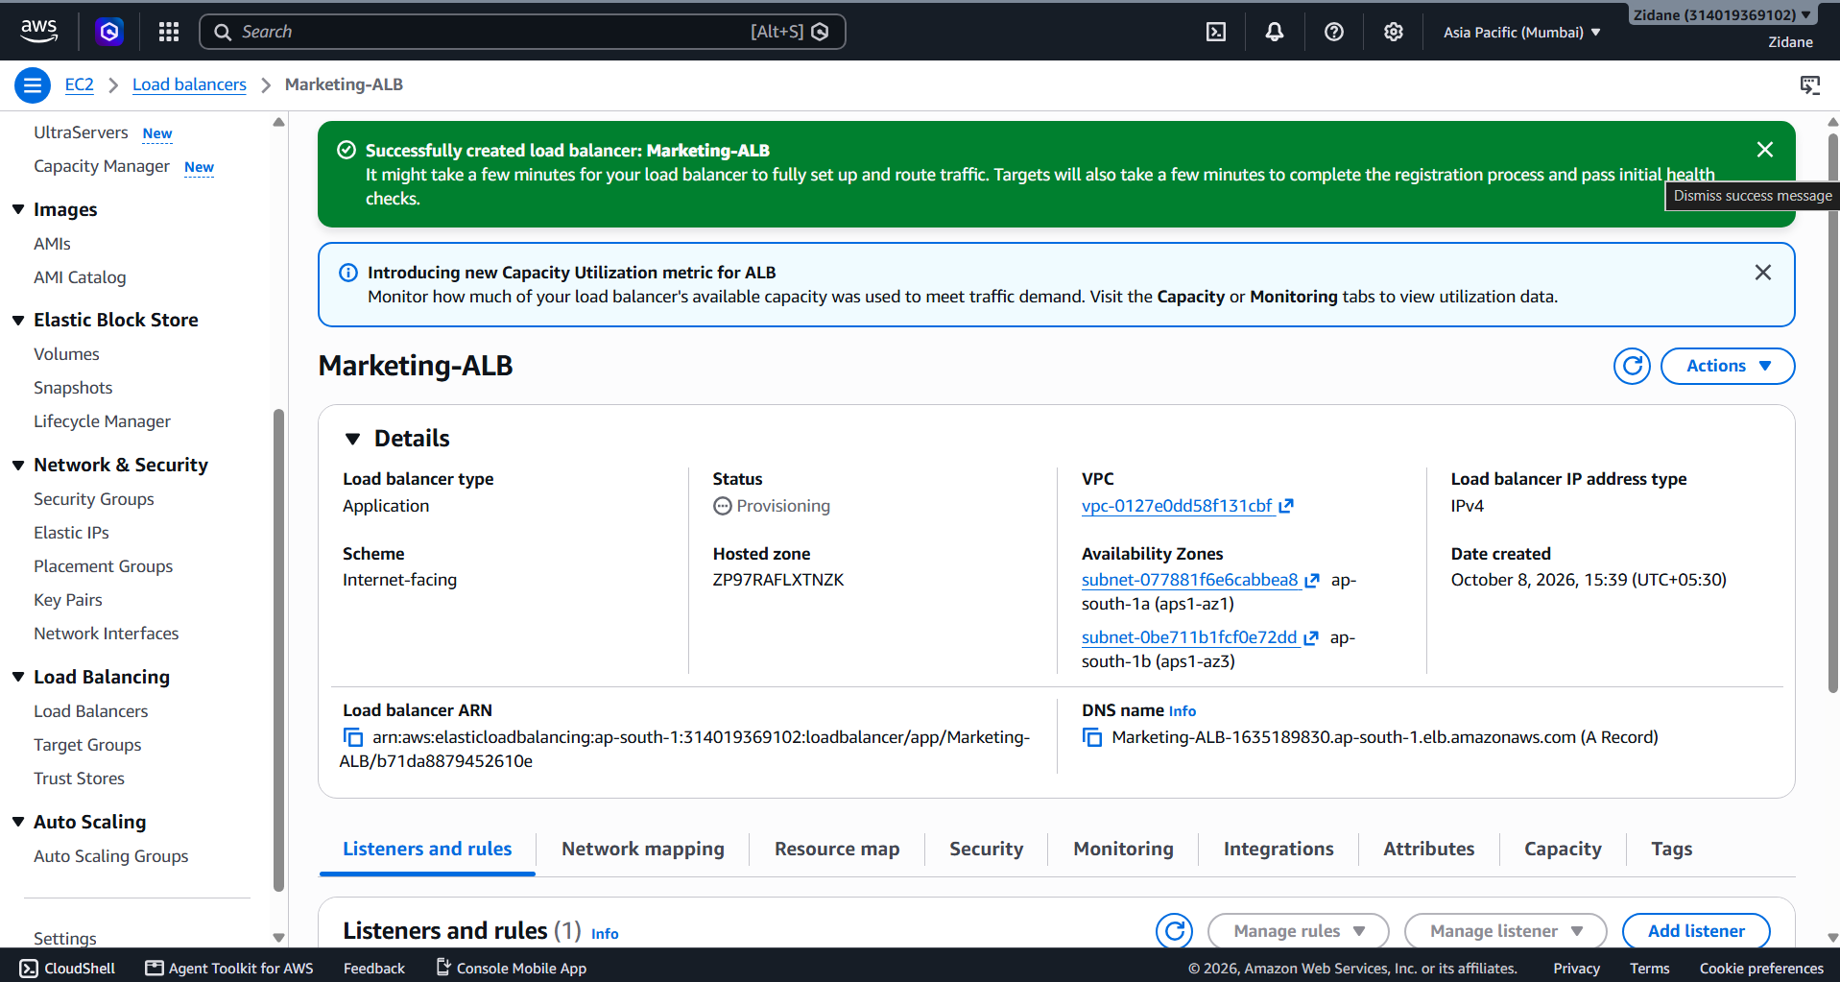
Figure 3: Application Load Balancer Marketing-ALB created (internet-facing, ap-south-1a and ap-south-1b)
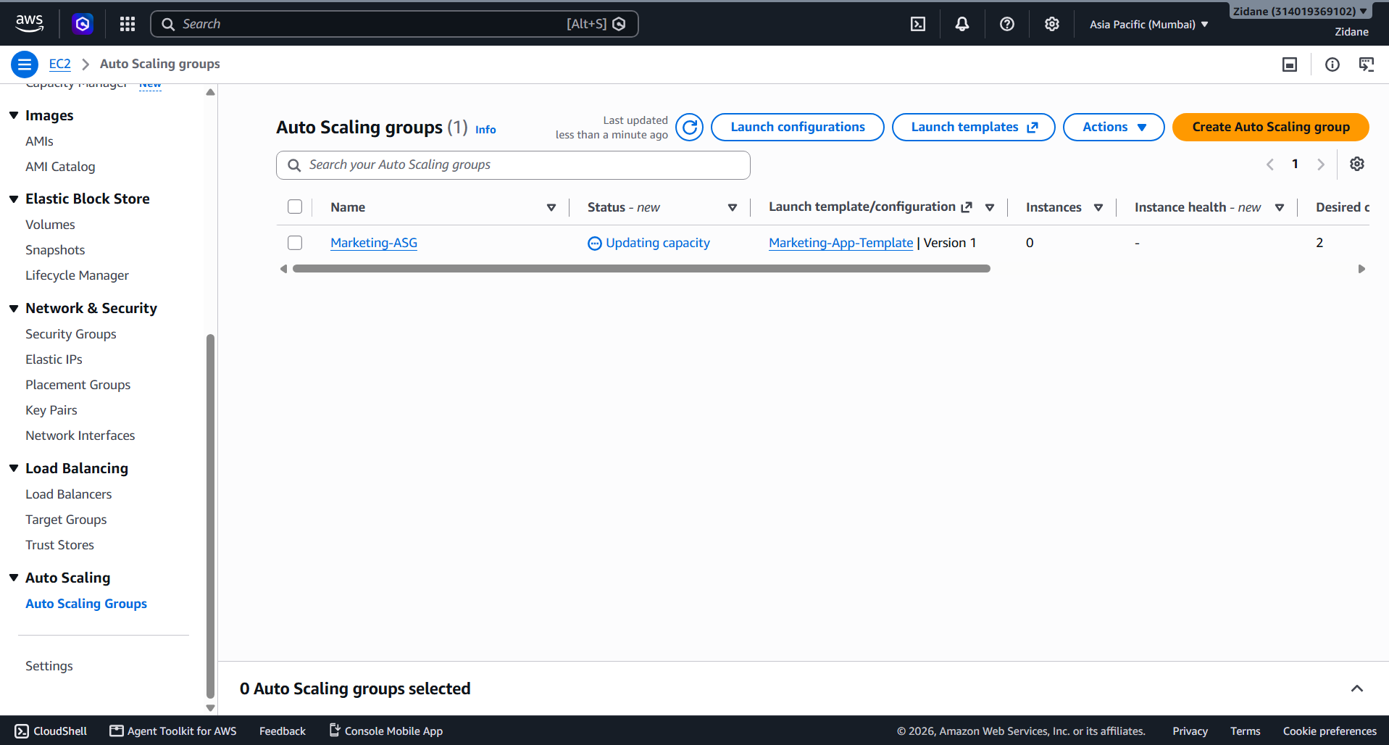
Figure 4: Auto Scaling group Marketing-ASG using Marketing-App-Template, updating capacity with desired capacity 2

7. Important Configurations
- Multi-AZ: instances run in two Availability Zones (ap-south-1a and ap-south-1b), so the failure of one zone does not stop the application.
- Load balancer: Marketing-ALB is an internet-facing Application Load Balancer using IPv4 with a listener forwarding HTTP:80 traffic to Marketing-TG.
- Target group: Marketing-TG uses target type Instance, HTTP:80 and HTTP1; health checks mark instances Healthy or Unhealthy.
- Launch Template: Marketing-App-Template (Version 1) gives every new instance an identical configuration.
- Auto scaling: minimum 2, desired 2, maximum 6, target tracking on average CPU utilization at 50%.
- Health checks: ELB health checks plus a health-check grace period let the ASG replace unhealthy instances without removing instances that are still starting.
- Security: EC2 accepts traffic only from the ALB security group; RDS accepts traffic only from the EC2 security group; S3 Block Public Access enabled; IAM role instead of stored credentials.
- Cost: the ASG scales back to 2 instances after the surge, so extra capacity is paid for only while needed.

8. Testing and Verification
- Target group: Open Marketing-TG and confirm that the registered targets from both Availability Zones become Healthy.
- Load balancer: Open the DNS name of Marketing-ALB in a browser and confirm that the application page loads.
- Auto Scaling group: Confirm that Marketing-ASG launches 2 instances (one per Availability Zone) and that its status changes from Updating capacity to normal.
- Load test: Generate heavy traffic (for example with Apache JMeter or Locust) and watch CPUUtilization in CloudWatch rise above 50%.
- Scale out: Check the ASG Activity history to see new instances launched, up to the maximum of 6.
- Failure test: Stop one instance and confirm the ALB stops sending traffic to it and the ASG replaces it.
- Scale in: After the load stops, confirm that the ASG reduces capacity back to 2 instances.
- Deployment: Push a change to GitHub and confirm that CodePipeline builds and deploys it to the instances.

9. Expected Output / Result
The load balancer Marketing-ALB, target group Marketing-TG and Auto Scaling group Marketing-ASG were created in the Asia Pacific (Mumbai) region. The Auto Scaling group is launching its desired capacity of 2 instances from Marketing-App-Template. During the 50× surge the application is expected to stay available, instances are added automatically when CPU utilization goes above 50% (up to 6) and removed when load falls, and traffic continues if one instance or Availability Zone fails. Measured load-test figures can be recorded after the load test is performed.

10. Conclusion
The single-instance bottleneck and single point of failure are removed by using an Application Load Balancer and an Auto Scaling Group across two Availability Zones, with CPU-based scaling, health checks, S3, EBS, RDS, CloudWatch monitoring and an automated GitHub-to-EC2 CI/CD pipeline. This gives a scalable, highly available, secure and cost-efficient solution for the 24-hour 50× traffic spike.

